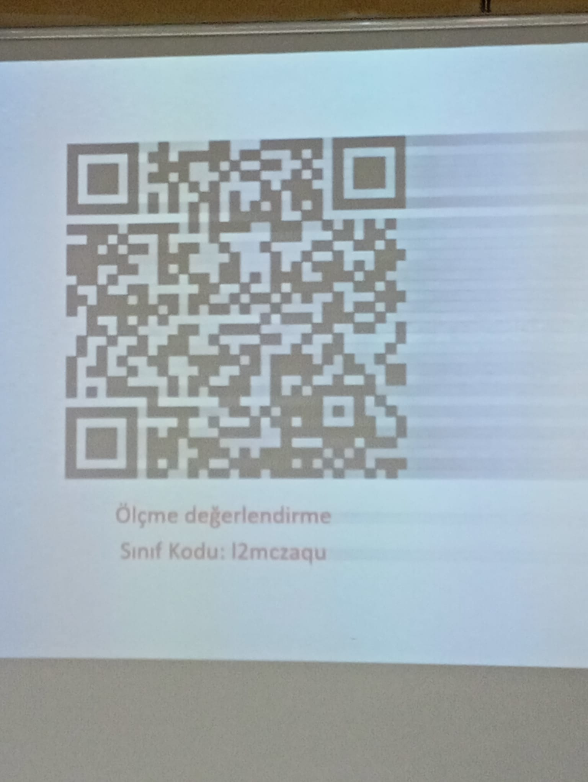

<https://classroom.google.com/c/ODExMTc5Mzg3OTg2>

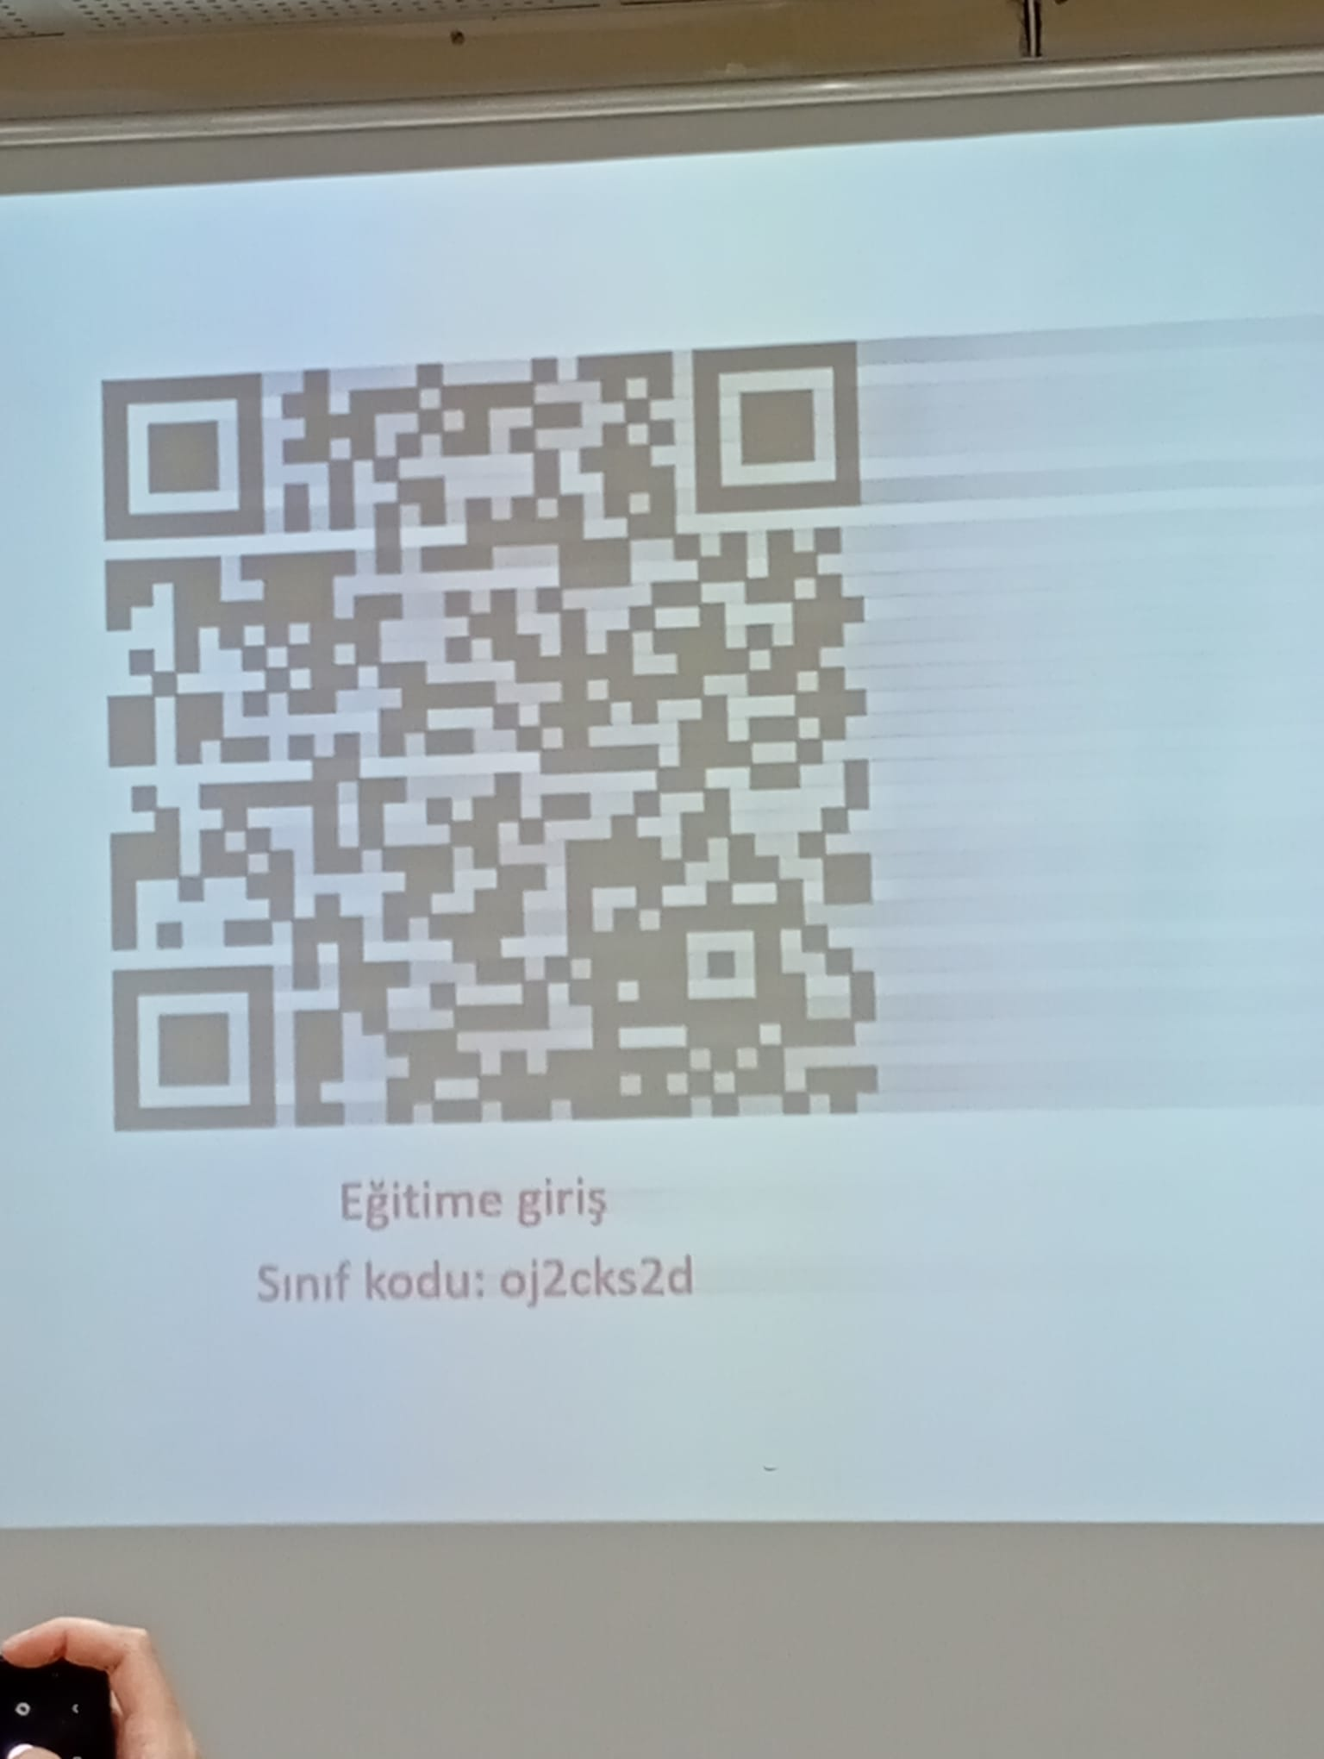

<https://classroom.google.com/c/ODExMTgwMjc1MzYy>